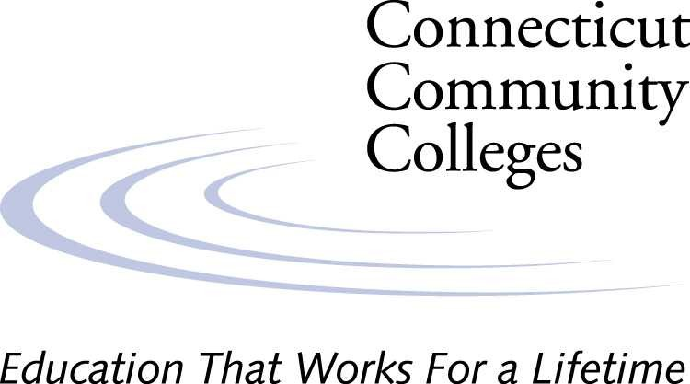

Press Release

For immediate release For additional information, contact:
September 2, 2005 Meghan Collins, Director of Government Relations
860-965-7800 – mcollins@commnet.edu

Connecticut Community Colleges Authorize Tuition and
Fee Waivers for Displaced Higher Education Students

In response to the catastrophic consequences of Hurricane Katrina, the Connecticut Community Colleges are joining other higher education institutions in offering assistance for the Fall 2005 semester to students displaced from colleges and universities affected by the hurricane. The Board of Trustees, working with the Presidents of the twelve colleges, quickly passed a resolution implementing the process of registering students into courses, on a space available basis, and authorizing the waiver of tuition and fees. Waivers will be considered for both Connecticut residents who may have been enrolled to attend institutions whose operations have been disrupted by the catastrophe, as well as for displaced students from other states who may have temporarily relocated to Connecticut. Each college will work individually with affected students to establish eligibility and need.

In addition, the resolution recognizes the fact that as classes are already underway at many of the Community Colleges, the colleges are authorized and encouraged to offer appropriate academic counseling and testing, financial advising, as well as expedited admissions to assist such students in identifying and registering for available courses that will enable them to continue their academic progress until such time as they are able to return to their original institutions.

Marie Spivey, Vice Chair of the Board of Trustees, authorized an immediate poll of all Trustees. A majority yea vote resulted in the immediate execution of the resolution. Ms. Spivey expressed satisfaction that the Connecticut Community Colleges were able to offer this gesture of support to some of the victims of this disaster and the hope that any students who were able to take advantage of this opportunity would be relieved of at least some of their distress.

Dr. Murali Atluru, a member of the Board of Trustees, worked vigorously with the administration to help bring about this result. He and his wife have also personally offered to serve as a host family for two students in need. The Board of Trustees, the administration, and the Presidents of the twelve Community Colleges, with their staff and faculty, are committed to this gesture of help and the hope that the students and institutions of higher education affected by this misfortune will soon be able to recover.

